Operating Instructions Piston Burettes
T 90/10
T 90/20
T 90/50
TABLE OF CONTENTS PAGE
1 Equipment description 25
2 Technical principle 25
3 Technical data of the Piston Burette T 90 26
4 Warning and safety instructions 27
5 Setting up and commencing operation 28
6 Dosing unit 29
7 Titrating with the Manual Titration Controller TR 160 30
8 Titrating with the Titrators and the Titration Recorder TS 165 31
9 Status displays of the Piston Burette T 90 31
10 Inputs and outputs of the Piston Burette T 90 32
Abb. 1: Kolbenbürette T 90/20
Fig. 1: Piston Burette T 90/20
Fig. 1: Burette à piston T 90/20

Abb. 2: Vorderseite der Kolbenbürette T 90/.. mit demontiertem Ventil
Fig. 2: Front view of the Piston Burette T 90/.. with valve detached
Fig. 2: Face avant de la Burette à piston T 90/.. avec vanne démonté

1 PTFE-Dosierschlauch | 2 Arretierungsring | 3 Anzeige “Füllen“
PTFE dosing hose | Locking ring | “Fill“ display
Flexible de dosage PTFE | Bague d’arrêt | Affichage “Remplissage“
4 Volumenanzeige | 5 Netzschalter | 6 Stativhalterung
Volume display | Mains switch | Clampstand holder
Affichage de volume | Interrupteur secteur | Support de statif

7 Bürettenspitze, Typ Nr. TZ 1503 | 8 Stativstange, Typ Nr. 1510
Burette tip, type no. TZ 1503 | Clampstand rod, type no. TZ 1510
Pointe de burette, type no. TZ 1503 | Tige de statif, type no. TZ 1510
9 Elektroden-Klammer, Typ Nr. Z 331 | 10 PTFE-Ansaugschlauch
Electrode clip, type no. Z 331 | PTFE suction hose
Pince pour électrode, type no. Z 331 | Tuyau d’aspiration PTFE
11 Abtropfglas, Typ Nr. TZ 1507 | 12 Ventilabdeckung
Drip glass, type no. TZ 1507 | Valve cover
Tube d’égouttage, type no. TZ 1507 | Couvercle en vanne
13 PTFE-Kegelventil, Typ Nr. TZ 1500
PTFE conical valve, type no. TZ 1500
Vanne conique PTFE, type no. TZ 1500

Abb. 3: Rückseite der Kolbenbürette T 90/..
Fig. 3: Rear side of the Piston Burette T 90/..
Fig. 3: Face arrière de la Burette à piston T 90/..

1 Fülltaste | 5 37polige Buchse für Anschluß von Titrierhandregler TR 160,
Fill button | Titratoren, Titrationsschreiber TS 165
Touche de remplissage | und externe Steuerungen
2 Typenschild | 37-pole socket connector for Manual Titration
Type specification plate | Controller TR 160, Titrators, Titration Recorder TS 165
Plaque | for externel control functions
3 Netzanschluß | Fiche 37 pôles pour raccordement avec
Mains connection | le Régulateur manuel de titration TS 165, Titrimètres,
Raccordement secteur | Engeregistreur de titration TS 165 et commandes externes
4 Sicherungshalter 0,125 A träge | 6 Dosieraufsatz für: T 90/10: Type no. TZ 1411
Fuse holder 0,125 A slow blow | Dosing assembly for: T 90/20: Type no. TZ 1412
Fusible 0,125 A retardé | Unité de dosage complète pour: T 90/50: Type no. TZ 1415

Abb. 4: Montieren der Stativstange der Kolbenbürette T 90/..
Fig. 4: Mounting the clampstand rod of the Piston Burette T 90/..
Fig. 4: Montage de la tige de statif de la Burette à piston T 90/..

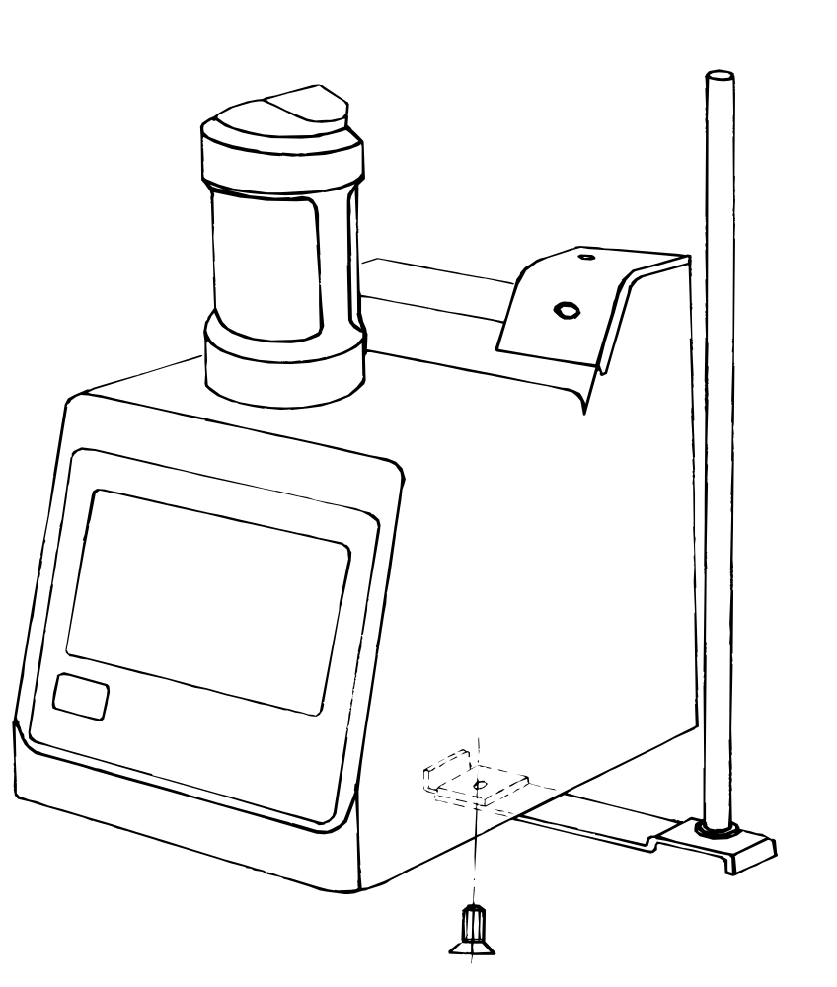

Abb. 5: Demontierter Dosieraufsatz, Ausführung ab 94 für Kolbenbürette T 90
und Schlauchgarnitur TZ 1425
Fig. 5: Dismantled dosing unit, model starting from 94 for Piston Burette T 90
and set of hoses TZ 1425
Fig. 5: Dispositif de dosage démonté, à partir de 94 pour Burette à piston T 90
et jeu de flexibles TZ 1425

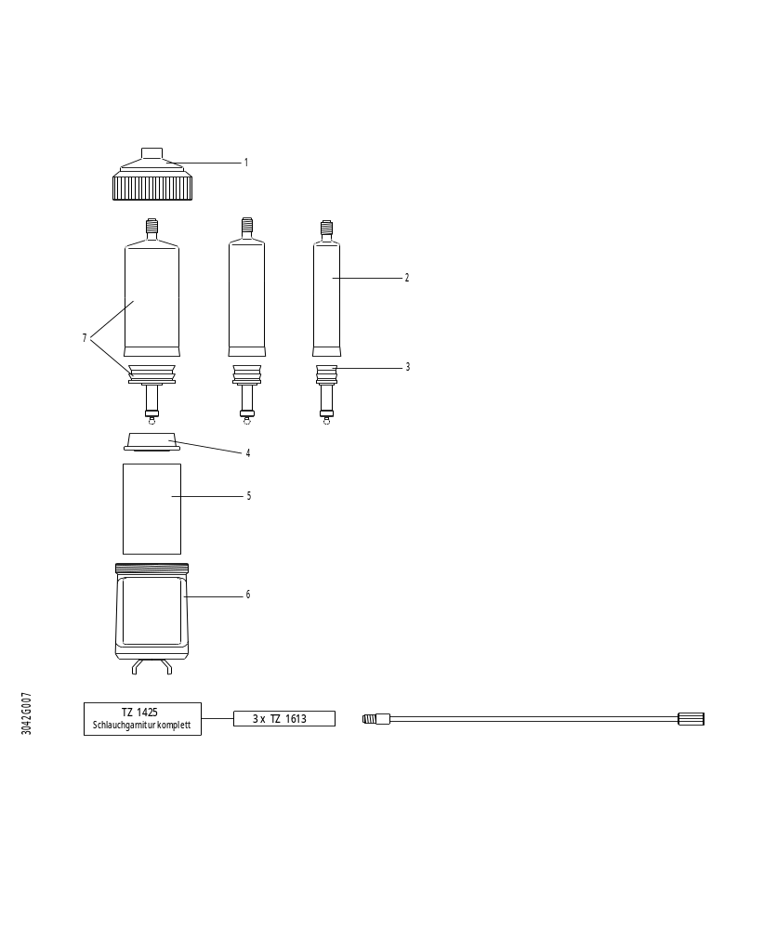
T 90/10: Typ Nr. TZ 1261
T 90/20: Typ Nr. TZ 1262
T 90/50: Typ Nr. TZ 1265
7DURAN® Bürettenzylinder mit
PTFE-Kolben und Kolbenstange
DURAN®burette cylinder with
PTFE piston with piston rod
Cylindre de burette DURAN® avec
piston PTFE, tige de piston et couvercle
6Schutzkorb
Protection basket
Cage de protection
5UV-Schutzmantel TZ 1430
UV protection sheath TZ 1430
Enveloppe protectrice UV TZ 1430
4Zentrierring
Centering ring
Bague de centrage
3PTFE-Kolben mit Kolbenstange
PTFE piston with piston rod
Piston PTFE avec tige de piston
2DURAN® Bürettenzylinder
DURAN® burette cylinder
Cylindre de burette DURAN®
1Abdeckhaube
Covering hood
Couvercle

Abb. 6: Dosieraufsatz, demontiert, für Kolbenbürette T 90/.., Ausführung bis einschließlich 93
Fig. 6: Dosing unit, dismantled, for Piston Burette T 90/.., model thru 93
Fig. 6: Dispositif de dosage, démonté, pour Burette à piston T 90/.., modèle jusque 93 inclus
Dosieraufsatz für:
Dosing assembly for:
Unité de dosage complète pour:
T 90/10: Typ Nr. TZ 1411
T 90/20: Typ Nr. TZ 1412
T 90/50: Typ Nr. TZ 1415
1 Verschraubung
Screw fitting
Raccord à vis
2 Abdeckhaube
Covering hood
Bague de centrage
3 Zentrierring
Centering ring
Bague de centrage
4 Schlauchverbindung: Ventil ↔ Zylinder
Hose connection: valve ↔ cylinder
Connection de tube: vanne ↔ cylindre
5 DURAN®-Bürettenzylinder mit
PTFE-Kolben, Kolbenstange und Deckel:
DURAN® burette cylinder with
PTFE piston, piston rod and lid:
Cylindre de burette DURAN® avec
piston PTFE, tige de piston et couvercle:
T 90/10: Typ Nr. TZ 1401
T 90/20: Typ Nr. TZ 1402
T 90/50: Typ Nr. TZ 1405
6 UV-Schutzmantel, Typ Nr. TZ 1430
UV protection sheath, type no. TZ 1430
Enveloppe protectrice UV, type no. TZ 1430
7 Schutzkorb
Protection basket
Cage de protection

Abb. 7: Titrierhandregler TR 160
Fig. 7: Manual Titration Controller TR 160
Fig. 7: Commande manuelle TR 160

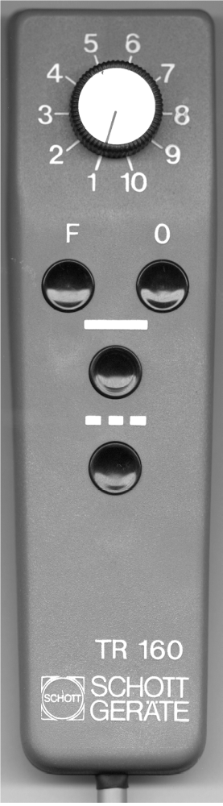
Füllen
Fill
Remplissage
Stufenschalter für Titriergeschwindigkeiten
Step switch for titration speed
Sélecteur de vitesse
Kontinuierliches Titrieren
Continuous titration
Titration en continu
Null-Stellen der Anzeige
Display zero reset
Remise à zéro de l’affichage
Titrieren in Teilschritten von 0,010 ml
(bei 1 ml-, 5 ml-Bürette) bzw. 0,10 ml
(bei 10 ml-, 20 ml-, 50 ml-Bürette)

Titration in steps of 0.010 ml
(with 1 ml, 5 ml burette) or 0.10 ml
(with 10 ml, 20 ml, 50 ml burette)

Titration en pas de
0,01 ml pour les burettes de 1 ml et 5 ml
0,1 ml pour les burettes de 10 ml, 20 ml, 50 ml
Anschlußkabel
Connection cable
Câble de raccordement

Equipment description
The Piston Burettes of type T 90 are microprocessor-controlled burettes with automatic valve switching.
Three different versions are available:
T 90/10 with a volume of 10 ml
T 90/20 with a volume of 20 ml
T 90/50 with a volume of 50 ml
All burettes in the T 90 range have a 37pole socket as data input and output (see fig. 3). This permits full integration of the burettes in the titration system from SCHOTT-GERÄTE.
All kinds of titrations can be carried out, from simple manual titrations to fully automatic computer supported titrations.
Peripheral equipment units
The Manual Titration Controller TR 160 must be connected to the Piston Burette T 90 for manual titrations.
An extensive range of electronically controlled titrators permits set-up of universal or special titration equipments.
Note: Dosings with the Dosing Programmer TD 130 are not possible with the Piston Burette T 90.
The utilized materials
All parts of the piston burette which come into direct contact with the titration reagent (cylinder, valve, piston and hoses) are made of DURAN® borosilicate glass or fluoro-hydrocarbon polymers. These materials are highly resistant to chemical attack.
Attention: The case of the unit is not sealed with respect to gas and moisture, so that operation in corrosive vapours is not permitted.

Technical principle
The piston burette operates according to the piston stroke principle. The piston is driven by a microprocessor-controlled stepping motor.
The 37pole socket on the rear panel has the following functions:
- Connector for the Manual Titration Controller TR 160
- Connector for the titrators via the data cable TZ 1570
- BCD output for the display (bit parallel, byte serial)
- Logis status outputs for the Piston Burette T 90
- Pulse input for external control
- Pulse output for controlling peripheral units with the piston burette

Technical data of the Piston Burette T 90
CE mark: according to the Council Directive 89/336/EMC (electromagnetic compatibility);
generic emission according to standard EN 50 081, Part 1
generic immunity according to standard EN 50 082, Part 2
according to the Council Directive 73/23/EMC (low-voltage directive),
last modified by the Council Directive 93/68/EMC
testing basis EN 61 010, Part 1
Country of origin: Germany / made in Germany
Volume display: 14 mm LED display, 4 digits, correct decimal point position,
0.01 ... 99.99 ml
Display tolerance: ± 0.01 ml
Dosing accuracy: ± 0.1% of total volume
Reproducibility: ± 0.05 % of total volume
Piston drive: pulse-controlled stepping motor, max. frequency = 330 Hz
for external drive (10000 pulses for 100% volume)
Cylinder: T 90/10; 10 ml, DURAN® borosilicate glass
T 90/20; 20 ml, DURAN® borosilicate glass
T 90/50; 50 ml, DURAN® borosilicate glass
UV-protection: protection sheath, brown, as standard feature
Filling speed: T 90/10 and T 90/20: 30 s
T 90/50: 60 s
Ejection speeds: with titrators:
fastest ejection: 100% in 30 s
slowest ejection: practically infinite time
with Manual Titration Controller TR 160
100 % in 120 s ... 100 % in 30 s
Valve: volume-neutral conical valve made of fluorohydrocarbon
polymers
Valve switching: automatic
Hoses: PTFE with brown UV protection
Mains connection: 230 V or 115 V alternating voltage, 50 ... 60 Hz
Power consumption: 30 VA
Data output: BCD, bit parallel/byte serial (SCHOTT-GERÄTE interface)
for volume
Case: Materials: Polypropylene, brilliant blue, rear panel, front window:
aluminium with two-component coating
Dimensions: 148 x 310 x 210 mm (W x H x D)
Weight: about 3.5 kg
DURAN® = is a trademark of SCHOTT GLASWERKE, Mainz

Warning and safety instructions
For safety reasons the Piston Burette T 90 may only be opened by authorised persons. For example, work on the electrical equipment may only be performed by trained specialists. If the unit is opened without authorisation or if it is damaged maliciously or through negligence the guarantee is void.
The Piston Burette T 90 conforms to protection class I. It has been built, tested in accordance with
DIN 57 411, Part 1/VDE 0411, Part 1, Protection measures for electronic measuring instruments and left the factory in perfect technical condition. In order to maintain this condition and ensure safe operation the user must observe all the instructions and warnings contained in these operating instructions.
Before switching on it is to be ensured that the operating voltage set on the Piston Burette T 90 and the mains voltage are the same. The operating voltage is specified on the type plate.
Insert the mains plug only into a power socket which has safety grounding contact. The protection ground line must not be interrupted by an extension cable which does not have a corresponding ground conductor.
Any interruption of the protection grounding line inside or outside the apparatus, or disconnection of the grounding conductor, can produce dangerous states of the apparatus. Deliberate disconnection or interruption of the grounding line is forbidden.
Make sure that only fuses of the specified type and with the specified nominal current rating are used as replacement. The use of repaired fuses or short circuiting of the fuse holder is forbidden.
The Piston Burette T 90 must not be stored or operated in wet rooms.
If it must be assumed that it is not possible to operate the Piston Burette T 90 safely, it is to be taken out of operation and secured to prevent it being put back into operation unintentionally.
For safety reasons the Piston Burette T 90 is only to be used for the purposes described in these operating instructions. The relevant directives for dealing with dosed fluids must be observed. The user must ensure that the persons entrusted with using this piston burette are trained in dealing with the substances with the piston burette.
When working with fluids which are not conventional titration media, the chemical resistance of the materials of the Piston Burette T 90 must be particularly taken into account.
The following may be used:
- All normal titration solutions whereby the solutions specified in the "Küster-Thiel" calculation tables (published by Walter de Gruyter) are to be taken as standard.
- Water and all non-aggressive, inorganic and organic fluids may be used as solvents. When handling inflammable substances the explosion protection directives of the Professional Association of the Chemical Industry are to be observed.
- It is not possible to dose liquids with a viscosity above 50 mm2/s.
When using liquids with a high vapour pressure and/or matters or mixed matters not qualified for use, the user will be responsible for the safe and proper operation of the piston burette.
When the piston rises in the cylinder a microfilm of the dosed fluid remains on the internal wall of the cylinder each time but this has not influence on the dosage accuracy. The minimal residue of fluid may evaporate, however, and thus get into the zone beneath the piston and corrode or dissolve the materials used there.
The Piston Burette T 90 is equipped with integrated circuits (EPROMs). These circuits (ICs) can be deleted by X-rays, radioactive rays or UV rays. Whilst UV rays can be completely reflected by the housing, X-rays or other high energy rays may penetrate the housing and delete the program.

Setting-up and commencing operation
Unpacking the piston burette
The piston burette and all accessory parts as well as the peripheral equipment units have been carefully tested in the factory for proper functioning and correct dimensions.
Please make sure to unpack all small accessory items (see fig. 2).
List of parts: 1 piston burette, 1 mains cable, 1 drip glass,
1 burette tip, 1 suction tube, 1 electrode clip with burette tip holder
1 stand holder, 1 stand rod, 1 piston extractor.
Mounting the clampstand rod
Latch the clampstand holder into the base of the piston burette and fix it with the provided cross-slit screw (see fig. 4).
Setting up the piston burette
The piston burette can be set up on any convenient level surface. Plug the mains cable into the mains input socket on the rear side and insert the mains plug on the other end of the cable into the mains power outlet (see fig. 3). Make quite sure that the electrical safety regulations are obeyed.
Attention: The piston burettes are equipped with a freely programmable microprocessor. The program data can be erased by ultraviolet radiation, X-rays or nuclear radiation. The case gives complete shielding against ultraviolet radiation, but X-rays and nuclear radiation can penetrate the case and erase the data in the microprocessor.
Connecting a peripheral unit
The Manual Titration Controller TR 160 can be connected by inserting its permanently attached plug into the 37pole socket on the rear panel of the Piston Burette T 90 (see fig. 3).
Titrators or the titrator recorder can be connected to the piston burette with the data cable TZ 1570.
The plug has a non-symmetrical edge, so that it is possible to insert it only the right way round. Do not exert force, to prevent damage to the plug connector system.
First fill and rinsing program
The first fill and rinsing program is started by pressing the button on the rear side of the burette. The piston burette now immediately starts executing the first fill and rinsing program.
Display: <<F--.-->>.
The fill key on the rear side of the Piston Burette T 90 must be used when a titrator is connected. The first fill and rinsing program can not be started via the fill key of a connected titrator.
The piston first runs automatically to the bottom position. The cylinder contents (air or old reagent) are then ejected. When the top position has been reached, a fill cycle starts, whereby fresh reagent is sucked in. The complete cylinder volume is ejected again on reaching the bottom piston position. The cylinder is then filled again and, after making compensation for play, the display is switched to <<00.00>>. A waste catch vessel must be placed under the burette tip whilst this first fill and rinsing program is running.
When changing the reagent, a drag-over of about 0.2 % must be contended with after two complete rinsing cycles. In view of this fact, it is necessary to decide whether work shall be continued after several rinsing cycles or after dismantling, cleaning and reassembling or after fitting another dosing unit of the same size.
The Piston Burette T 90 is then ready for making the next titration.

Dosing unit
Changing the dosing unit
The burette cylinders can be replaced only by one of the same size, because each piston burette is adjusted for the specified size. The piston must be brought to the lowest position before the dosing unit can be changed. For this purpose, initiate he fill command by briefly pressing the <F> button on the Manual Titration Controller TR 160 or the fill button on the rear side of the Piston Burette T 90 of the <FÜLLEN/FILL> key on the connected titrator.
The piston is in the bottom position after execution of the fill command. Now disconnect the hose between the valve and the dosing unit at the valve (unscrew the black valve cover and turn out the square head screw) and turn the lock ring such that the opening points to the front.
The dosing unit can very easily be taken out of the guide, to the front.
To mount the dosing unit, proceed in reversed sequence.
An interlock prevents push-in of the assembly in the wrong direction. Please do not use force when pushing-in. For adjustment, pull out the piston to the stop using the piston puller. After pressing the dosing unit onto a level surface, the piston is adjusted to the correct height and the dosing unit can then be pushed again easily.
Changing a glass cylinder
First take off the dosing unit from the Piston Burette T 90 as described above. The screw fitting can then be released at the top on the unit (see fig. 5 or fig. 6) and taken off together with the covering hood. The still closed cylinder with piston, lid and hose can now be taken out of the protection basket. The hose, lid or piston can then be dismantled with ease, for cleaning or for replacement.
To assemble proceed in reverse sequence:
- Press the piston from above downwards into the glass cylinder.
- Place the cover with gasket ring (PTFE part) onto the glass cylinder.
- Screw the ends of the short hose connection (with two square screw fittings) into the lid.
- Push the UV protection sheath into the protection basket. The protection sheath will fit into the opening only one way round, thus turn it round if necessary.
- Place the cylinder in the protection basket with the piston down.
- Mount the centering ring and the hood such that the hose is bent over to the rear. Position the dosing unit such that the twist lock device on the dovetail guide faces to the front.
Mount and tighten the screw fitting. Adjust the piston height by pressing onto a flat surface and then push-on the dosing unit. Now establish the hose connection from the dosing unit to the valve and close the lock ring.
Whilst carrying out these tasks, bear in mind the sensitivity of PTFE to mechanical stress. Even slight carelessness can lead to dents and scratches which will cause the dosing unit to leak.
The piston burette is now ready again for operation.

Titrating with the Manual Titration Controller TR 160
All manually controlled titrations are carried out with the Manual Titration Controller TR 160. The manual controls provided for this purpose comprise a BCD-encoded 10-step switch and 4 press buttons.
All buttons are logically interlocked mutually. When any button is pressed, the piston burette will not respond to any other command until the running process has been completed.
The rotary switch and the press buttons have the following functions (see fig. 5).
The rotary switch
Ten different titration speeds can be selected with the rotary switch. The titration speed may also be changed during a titration, by turning this switch. Position “1“ means slowest speed (100 % burette volume in 300 s). A useful feature for manual titration is the possibility for direct switch-over from fastest to slowest titration speed (position 10 to position 1) or conversely.
The press button <F>
The press button <F> (Fill) starts the fill cycle for the burette from any arbitrary initial piston position. A brief press of this button is sufficient. The filling time for the entire cylinder is 30 seconds for T 90/10 and
T 90/20 and 60 seconds for T 90/50. For the duration of the filling process, “F“ appears in the display in addition to the previous volume read-out.
The press button <0>
By pressing the button <0>, the display of the piston burette can be reset to <<00.00>> without refilling. When the titer volumes are small, several titrations can be carried out in succession in this manner without refilling
Before the dosing unit can be changed, always first briefly press the fill button to move the piston to the bottom end position.
The press button <—>
When this button is pressed, reagent is ejected at the speed set with the rotary switch, for as long as this button is held depressed. The cumulative ejected volume is shown continuously in the display of the piston burette.
If this button is pressed only briefly (for less than 0.3 seconds), then always exactly 0.01 ml is dosed.
If the upper limit switch of the Piston Burette T 90 is reached during the titration (flashing volume display), then the display is not reset to <<00.00>> after a normal fill cycle (<F> pressed briefly), but the subsequently ejected volume is added onto the previously ejected volume (up to max. 99.99 ml). If this volume addition is not desired, then the button <0> must be pressed to reset the display to <<00.00>>.
The press button <--->
Volumes are ejected in 0.10 ml steps by pressing this button. The size of these steps is programmed to this fixed value which can not be changed externally. A brief press of this button is sufficient; prolonged pressing has no further effect. The dosing speed is set with the rotary switch.

Titrating with the titrators and Titration Recorder TS 165
All titrators and the Titration Recorder TS 165 from SCHOTT-GERÄTE can be connected to the Piston Burette T 90 via the data cable TZ 1570. All functions are carried out in corresponding manner by the titrators. For further details please consult the respective operating instructions. The first fill and rinsing program must be started by pressing the fill button on the rear side of the Piston Burette T 90, even when a titrator is connected.

Status displays of the Piston Burette T 90

Display | Meaning | Next operation
<<88.88>> | Segment test immediately  after switch-on. | Give the fill command.
<<F 88.88>> or, e.g.  <<F 12.68>> | Normal fill program is running.
<<F --.-->> | First fill and rinsing program is running.
<<00.00>> | The piston burette is ready  for starting titrations.
<<20.00>> ml flashing | The upper piston position | Give the fill command. The indicated
 | has been reached. | volume is retained when the TR 160
<<12.68>> ml flashing | The upper piston position | is connected. The subsequent
 | has been reached. | consumption is added thereto
 | (Reset to 00.00 was given before titration). | up to max. 99.99 ml.
 |  | Set to 00.00 for new titrations.

Inputs and outputs of the Piston Burette T 90
The inputs of the piston burette are connected to + 5 V via 10 kΩ pull-up resistors, so that a proper logic state exists even when nothing is connected. To activate a function, the corresponding input is switched to logic ground potential.
The output of the piston burette are implemented with type 74 LS 05 integrated circuits. Pull-up resistors to + 5 V must be connected on the user side.
The outputs are active low, i.e.: 0 V = logical 1,
+ 5 V = logical 0.
The address and data lines are encoded in 8421 form.
Inputs and outputs of the Piston Burette T 90
PIN no. Input = “I“ Function
Output = “0“

1 not connected
2 not connected
3 0 + 5 V logic level via 470 Ω
4 0 address bit rank 2
5 0 address bit rank 1
6 0 address bit rank 4
7 0 data bit rank 2
8 0 data bit rank 4
9 0 not filled
10 not connected
11 0 T 90 is in bottom position and display = <<00.00>> (ready)
12 0 T 90 is filling
13 I set display to zero
14 I speed of TR 160, rank 8
15 I speed of TR 160, rank 1; for titrators
and chart recorder, etc,. step pulse input
16 I fill command
17 I encoding for TR 160
18 not connected
19 I encoding for TR 156, TR 151, TR 152, TR 154,
TS 165 (external control drive signals)
20 not connected
21 (0) not used for T 90; print for titrators
22 0 active high, display enable
23 0 active high; write pulse for display memory
24 0 data bit rank 1
25 0 decimal point
26 0 data bit rank 8
27 not connected
28 0 executed step pulses
29 0 the piston of the T 90 is moving back
30 0 the upper limit switch has been reached
31 I speed of TR 160, rank 2
32 I speed of TR 160, rank 4
33 I dosing continuous for TR 160; start for titrators
34 I incremental dosing for TR 160; stop for titrators
35 ground
36 ground
37 ground

